**Practical 04**

**Aim:** Write a Python Program to work with databases in Python to perform operations such as:

a. Connecting to database

b. Creating and dropping tables

c. Inserting and updating into tables.

**SQLite**

SQLite is a self-contained, file-based SQL database. SQLite comes bundled with Python and can be used in any of your Python applications without having to install any additional software.

**Connecting to database**

conn = sqlite3.connect('databasename')

**Performing CRUD Operations**

1. Create
2. Read
3. Update
4. Delete

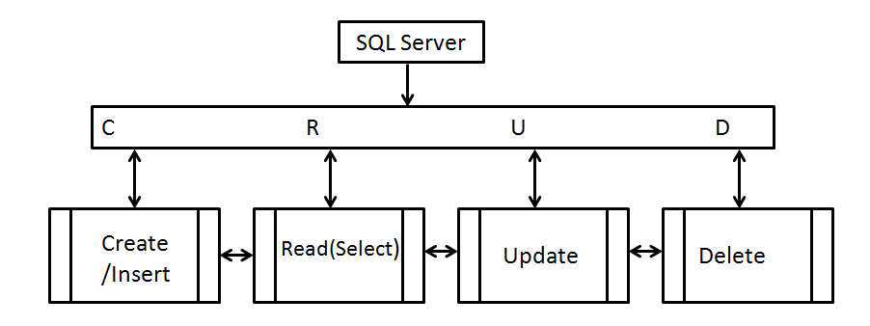

**Create**

Syntax:

CREATE TABLE <tablename>(column1 datatype, column2 datatype….)

**Insert**

Syntax:

INSERT INTO <tablename> VALUES (value1,value2,….)

**Read**

Syntax:

SELECT * FROM <TableName>

**Update**

Syntax:

UPDATE <TableName> SET Column1=Value1, Column2=Value2,… WHERE <Expression>

**Delete**

Syntax:

DELETE FROM <TableName> WHERE <Expression>